eDyscalculia: A Mobile Application for Helping Grade 3 Students

with Dyscalculia

Dumandan, Mary Grace R.

Fernan Joselle M.

Soriano, Mitzi Andrea D.

Technological Institute of the Philippines – Quezon City

**Chapter 1**

**Introduction**

Mathematical knowledge is one of the foundations of human cognitive and creative development. It is a basic tool for performing daily activities and encompasses various areas of knowledge. During childhood, mathematics is used for such tasks as dividing candy among friends, counting allowance money and tracking time while playing video games. During adulthood, mathematics is used for such tasks as tracking medication times and managing receipts, payments and finances.

However, individuals commonly have some type of difficulty in acquiring mathematical skills. The Program for International Student Assessment (PISA), Angel Gurría (2015) classifies mathematical proficiency in six levels, with level 6 being the highest. Approximately 90% of the countries evaluated by PISA had 10% or more of their students at level 1 .At this level the students are able to answer questions clearly defined involving familiar contexts and other relevant information. In sum, the students need to be able to identify information in explicit situations and also performing actions according to direct instructions.

Learning disabilities in mathematics include deficits in multiple mathematical abilities depending on the student's age and education level: counting in your head, number patterns, operations (addition, subtraction, division and multiplication), area and shape and size and measurement.

# Background of the Study

Dyscalculia is difficulty in learning or comprehending [arithmetic](https://en.wikipedia.org/wiki/Arithmetic" \o "Arithmetic), such as difficulty in understanding numbers, learning how to manipulate numbers, and learning facts in mathematics. It is generally seen as a [specific developmental disorder](https://en.wikipedia.org/wiki/Specific_developmental_disorder" \o "Specific developmental disorder).

Dyscalculia can occur in people from across the whole [IQ](https://en.wikipedia.org/wiki/IQ" \o "IQ) range – often higher than average – along with difficulties with time, measurement, and [spatial reasoning](https://en.wikipedia.org/wiki/Spatial_visualization_ability" \o "Spatial visualization ability). Estimates of the prevalence of dyscalculia range between 3 and 6% of the population. In 2004, it was reported that a quarter of children with dyscalculia had [ADHD](https://en.wikipedia.org/wiki/ADHD" \o "ADHD). In 2015, it was established that 11% of children with dyscalculia also have [ADHD](https://en.wikipedia.org/wiki/ADHD" \o "ADHD). Dyscalculia has also been associated with girls and boys who have [Turner syndrome](https://en.wikipedia.org/wiki/Turner_syndrome" \o "Turner syndrome) and people who have [spina bifida](https://en.wikipedia.org/wiki/Spina_bifida" \o "Spina bifida).

[Mathematical](https://en.wikipedia.org/wiki/Mathematical" \o "Mathematical) disabilities can occur as the result of some types of brain injury, in which case the proper term, [acalculia](https://en.wikipedia.org/wiki/Acalculia" \o "Acalculia), is to distinguish it from dyscalculia which is of innate, genetic or developmental origin.

# Project Objectives

The aim of the study is to improve people with dyscalculia which is a disorder that deals with arithmetic related tasks, and analyzing and solving math problems with the help of psychiatrists.

# Specific Objectives

Specifically, the study aims to:

* Develop a mobile learning application that will assess the skills of the student based from the prepared activities.
* Design a model that will assess the knowledge and skills of the student based from the prepared activities.
* Apply Randomized Quicksort algorithm to interpret the answers of the activities taken by the grade 3 students.
* Evaluate the mobile learning application in terms of usability, functionality and efficiency using the ISO 9126 software quality measurement as an evaluation tool.

**Significance of the Study**

The research study, eDyscalculia will contribute in significance to ICT:

* **Children with dyscalculia**

The person with dyscalculia can have a new tool in order learn identify numbers, patterns and signs in math problems.

* **Parents of the Children with dyscalculia**

The parents of the people with dyscalculia can have an alternative tool to teach their child about numbers, patterns, signs and equations.

* **Future IT Experts**

The future IT Experts can use our expert system as a reference or alternative tool in their future thesis**.**

**Scope and Delimitation**

The scope of this study is all about:

* Lesson Module – The application contains images, videos and all chapters of the lesson in Mathematics of the Grade 3 students.
* Pre-Test – Gives grade 3 students a test to determine what kind of activities they will answer based on the results of the test
* Activities – This is where the users test their knowledge to see if they understand the topic. It is composed of multiple choices, drag and drop, fill in the blanks, and input text.
* Progress Monitoring – Includes user accounts that can monitor the learning of the user.
* Test Results – Provide the test results of the grade 3 students and give them what level of dyscalculia they have.
* Related Videos and Articles – Allows grade 3 students to watch videos and read articles related to dyscalculia.
* Information about the Levels of Dyscalculia – Displays information about the levels of dyscalculia.
* Post-Test – Gives grade 3 students a test to determine if they understand the lessons and activities given by the application
* Simulation – This is where the grade 3 students learn conceptual knowledge inside or outside the classroom.
* Interactive Assessment – Gives grade 3 students a more fun way of answering the activities while learning.

**Delimitation**

* The application will be deployed on Android-based platform only
* The application was developed for persons with dyscalculia only
* The application will provide a set of questions about dyscalculia only that will be used to assess the condition of the patient
* The application is for grade 3 students only.

**Chapter 2**

# Theoretical Framework

# Review of Related Literature

The study conducted by Polat, et al. (2012) Because there is, currently, no education system for primary school students in grades 1-3 who have specific learning disabilities in Turkey and because such students do not receive sufficient support from face-to-face counseling, a needs analysis was conducted in order to prepare an adaptive, web-assisted learning system according to variables determined by the extent of learning disabilities. The scope of this study was limited to dyslexia, dyscalculia and dysgraphia. Data were collected from five subject area experts (psychologist and special education specialists) using semi-structured interview forms including open-ended questions, 15 parents, at least one of whose children has a specific learning disability and six classroom teachers via surveys including open-ended questions in the 2011-2012 academic year. A matrix diagram was prepared in order to analyze the data with a holistic approach and to show dependability and credibility of the study. The study revealed three main findings: a lack of information / interest about specific learning disabilities, the inadequacy of the Turkish Ministry of Education Specific Learning Disabilities Support Education Program, and the inadequacy of applications, both within and outside the classroom. The findings also showed that the students with specific mental disabilities need a web-assisted system that should be adaptive and which can be used both in school and at home. Based on this study, there is currently no education for young students ages 7-9 years old who have learning disability and most of them do not received any sufficient support from counseling. This study is limited for dyscalculia, dyslexia and dysgraphia. A matrix diagram was prepared in order to analyze the data with a holistic approach and to show dependability and credibility of the study. There are a lot of finding, one is lack of information, lack of interest and many more. Lastly there is a finding that the students with specific mental disabilities needs a web assisted system that should be user friendly and can be used at home. The significance of this study to our proposal is that it is about dyscalculia which is a learning disorder that ranges from 7 to 9 years old. Our difference is we have some experts but not a psychologist, in our said proposal, our expert is a psychiatrist. Lastly, our difference is we did not use a matrix diagram.

Computer-based training has been shown to be effective for areas such as language skills, auditory attention, working memory and reading skills (Loosli, Buschkuehl, Perrig, & Jaeggi, 2012; Stevens, Fanning, Coch, Sanders, & Neville, 2013). The use of computer technology has been shown to be not only effective in education in general, but in particular effective in mathematics, along with being effective for motivating students to engage in learning (Hasselbring, 2016; Li & Ma, 2012). An emerging area of psychological research is the impact of computer games on learning and cognitive processes, with research indicating that computer games of varying forms have a positive effective on cognitive processes and learning [(Eichenbaum, Bavelier, & Green, 2014; Green & Bavelier, 2015; Kühn, Gleich, et al. 2014), including, for example, helping children with dyslexia (Bavelier, et al. 2013).] Based on this study, using computers, tablets, and apps are a fact of a modern life that can also be used as an effective tool for working memory. Technology has been shown to be not only effective in educational in general but also it can be effective for mathematics, along with effective for motivating students to engage in learning. An emerging area of psychological research is the impact of computer games and cognitive processes. The significance of this study to our proposal is that the use of computer technology has been shown to be effective in Mathematics, along with being effective for motivating students to learn mathematics. Our Difference is that we didn’t use some computer games to vary forms to have a positive effect on cognitive process and learning.

Carlson (2015) reported that there is a vast difference between learning difficulty and learning disability; an individual with learning difficulty can learn using conventional teaching techniques while an individual with learning disability requires specialized interventions which depend on the type of disability. Learning disability can result from injury; it can be hereditary and it can come in many forms. In this study, Carlson said that a person with learning difficulty can learn using other teaching techniques. The significance of our proposal to this study is that our users will use our application as a teaching tool while our difference is we don’t differentiate learning difficulty and learning disability.

# Framework/DesignConcept

## **Figure 1.** Design Concept

To be able to create the eDyscallculia mobile learning application, programming skills in JAVA is a must and also the proper algorithm to be applied. The development of the project requires the hardware and software requirements. In this diagram, it includes specific requirements to create the proposed project. For the Knowledge Requirement, you should be aware of Symptoms Treatment for a people who have dyscalculia, and after knowing the symptoms you must have knowledge in Categorizing of symptoms exposure in order to come up with proper treatment management To come up with a working application hardware and software are needed. Desktop computer / Laptop as long as it has up to date hardware. To be able to run or use the application, smart phone must have at least an Android Version of 4.1 (Jelly Bean. Software requirement is needed to have a tool where you can program your application. The developers used Android Studio, Adobe Photoshop and SQLite Database Browser as a tool to develop the mobile application. Android Studio is the software used to program the application, while Adobe Photoshop is used for the design and layout of the application.

# UserSystem Architecture

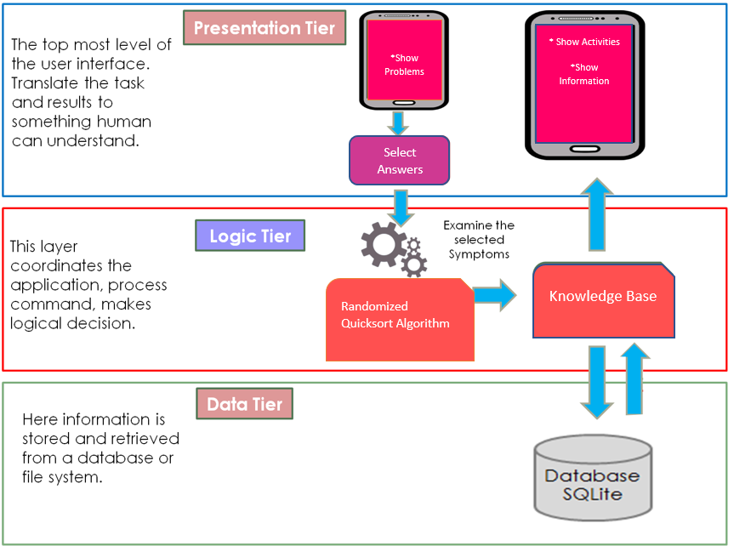

***Figure 2.*** *System Architecture for eDyscalculia*

This three-tier architecture shows the process of identifying the exposure condition of the patient. The application will process the information or data that have been inputted by the user to determine the exposure condition of the user. After analyzing the condition, the user will get the results if they have a disease called dyscalculia. Through the help of Decision Tree, the application will quickly give information and practices to help the user with the disorder.

# Presentation Tier

The top-most level of the application is the user interface. The primary function of the interface is to translate tasks and results to something the user can understand.

# Logic Tier

This layer coordinates the application, processes commands, makes logical decisions and evaluations, and performs calculations. It also moves and processes data between the two surrounding layers.

# Data Tier

Here information is stored and retrieved from a database or file system. The information is then passed back to the logic tier for processing, and then eventually back to the user.

# Definition of Terms

* **ADHD -** or **attention deficit hyperactivity disorder**, is a medical condition that affects how well someone can sit still, focus, and pay attention.
* **Algorithm** - is a procedure or formula for solving a problem.
* **Android SDK** - it is a tool for developing the eDyscalculia mobile application.
* **Arithmetic** - branch of mathematics that deals with the manipulation of numbers
* **Cognitive** - it is a psychological process that deals with the understanding knowledge
* **Database** - a structured set of data held in a computer, especially one that is accessible in various ways.
* **Disability** - it is a condition that limit's a person activities and senses
* **Dyscalculia** - is a specific learning disability involving difficulty in learning or comprehending arithmetic
* **Efficiency** - what can produce with the same consumption of resources
* **Mobile Application** - is a software application specifically for those who have a dyscalculia learning disorder that can be used on a small wireless computing devices, like smartphones and tablet.
* **Psychiatrist** - medical doctors who graduated from medical school
* **Psychologists** - have a doctoral degree in area of psychology, the study of human behavior
* **SQL** -  is a domain-specific language used in programming and designed for managing data held in a relational database management system (RDBMS), or for stream processing in a relational data stream management system (RDSMS).
* **Text-to-speech** - synthesis that converts text into spoken voice output

**Chapter 3**

**Research Methodology**

**Project Design**

In the proposed project, there are different tools defined to be used in developing the application. This project will be using Java as its main programming language, which will be deployed in Android. The platform to be used in developing the android-based application is Android Studio. Furthermore, this project will be utilizing the wide unique features offered by Photoshop CS6 in creating backgrounds, icons and images for the application. Moreover, the algorithm to be applied in the decision support system is Randomized Quicksort algorithm. This algorithm will be used to interpret the answers of the grade 3 students in their activities.

# Project Development

**RAPID APPLICATION DEVELOPMENT (RAD)**

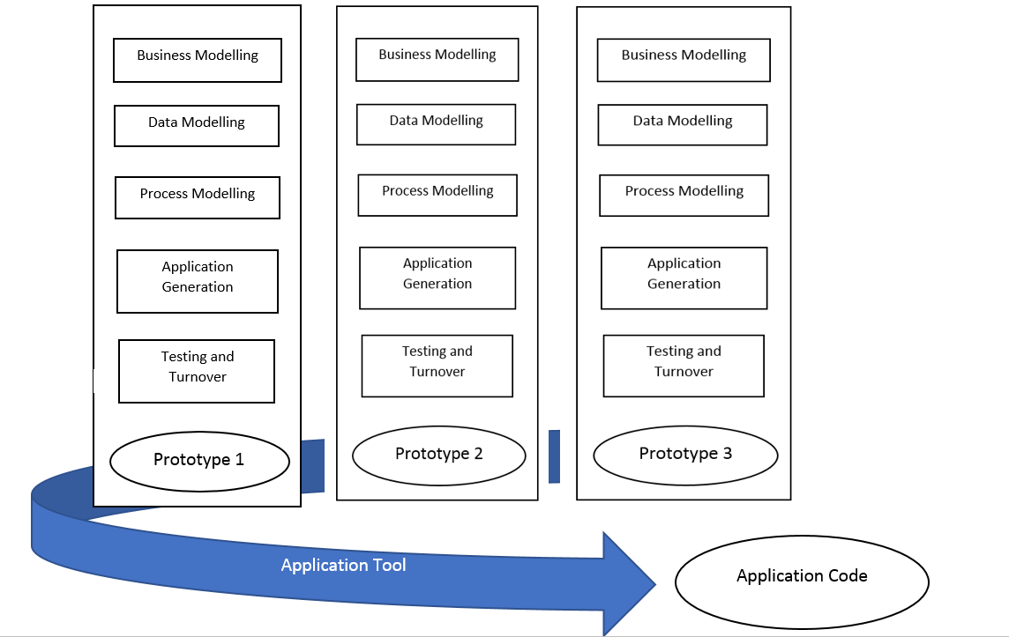

**Figure 3.** **Rapid Application Development Model Design**

Rapid application development (RAD) is a methodology that usesminimal time in planning to give favor in rapid prototyping, grantingsoftware to be created fast and makes an easy change of therequirement. RAD is the best use for projects where the objectives arewell enumerated and defined, data set for the project is existingalready, can quickly take the decision, the development team is small,and architecture of the project is well defined. We use this kind ofmethodology because the development time of the mobile app8licationmust be adjustable to the unexpected changes and decision from thetesting, checking and evaluation.

**Rapid Application Development Process**

**Business Modeling:** The business model for the study of development designed concerning flow and distribution of information between various business channels. And the researchers collected all the participants of the study or known as to be the target users and defined how to process the flow of information within the application.

**Data Modeling:** All gathered information from the Business Modeling phase is studied and analyzed to form sets of data objects essential for the business. And they identified all data sets and relation of data objects in relevance to the business model. And we defined the scope and delimitations of our study.

**Process Modeling:** The defined data object sets in the Data Modeling phase are converted to create the business information flow needed to acquire specific business objectives as per the business model. We have created the movement of information through how to obtain the objective of the study. Also, they defined an architectural prototype, development plan, any changes needed in this phase. And they also described the design of the application and how to make it feasible that can have the same interesting and useful feature for the target users.

**Application Generation:** The actual application is being constructed, and the coding is being done using automation tools to convert process and data models into prototypes. Automated tools are used to convert process models into the code and the actual application.

**Randomized Quicksort Algorithm:** is an [efficient](https://en.wikipedia.org/wiki/Algorithm_efficiency" \o "Algorithm efficiency) [sorting algorithm](https://en.wikipedia.org/wiki/Sorting_algorithm" \o "Sorting algorithm), serving as a systematic method for placing the elements of an [array](https://en.wikipedia.org/wiki/Array_data_structure" \o "Array data structure) in order. Developed by [Tony Hoare](https://en.wikipedia.org/wiki/Tony_Hoare" \o "Tony Hoare) in 1959 and published in 1961, it is still a commonly used algorithm for sorting. When implemented well, it can be about two or three times faster than its main competitors, [merge sort](https://en.wikipedia.org/wiki/Merge_sort" \o "Merge sort) and [heapsort](https://en.wikipedia.org/wiki/Heapsort" \o "Heapsort). We will apply it to our system specifically in our activities because our questions will appear randomly each time our user will use the application.

**Testing and Turnover:** When the prototypes independently tested during iteration, the overall testing time reduced in RAD model. However, the data flow and other components needed to test thoroughly. And due to the testing of most of the components, the risk of any major issues is reduced.

# Testing and Operating Procedure

We discussed the testing and operating procedure for eDyscalculia a Mobile Application for Helping Grade 3 Students with Dyscalculia

**Functional Testing**- we assured that every requirement in our application is working. Most of the test conducted is the user interface and the flow of the application.

**Performance Testing**- we also test the performance of our application to check the performance if it’s working fast and smoothly.

**Efficiency testing**- we will conduct an evaluation tool for the target users to evaluate.

**Installation testing**- we will install the application to the different version of an Android operating system with a minimum version of Android 4.2 (Jelly Bean) and another version, to ensure that our application is compatible to install in the specified Android version.

**Evaluation**

We used the ISO/IEC 9126 standard or Software Quality Standard as the basis for us to measure the acceptability of the application. We used criteria as usability, functionality and efficiency. And in order to determine the feasibility and usability of the application, we came up to a survey form based on ISO 9126 standard and have the responses scaled using the likert scale. A Likert scale is a psychometric scale commonly used in research that conducts surveys or questionnaires. Likert scale is the most widely used approach in scaling responses in survey research, such that the term is often used interchangeably with rating scale. With this approach, several degrees of agreement or disagreement, the respondents were asked in terms of usability, functionality and efficiency.

**Frequency Distribution**

The users scored this mobile application by giving five (5) as the highest score and (1) as the lowest.

**Table 1. Likert Scale**

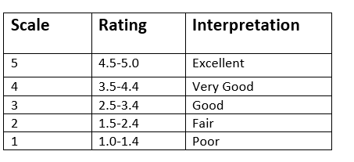

Table 1, shows the scale, rating and its equivalent interpretation used in the evaluation. That the user can rate the system according to the scale and rating provided. With an interpretation corresponds to every rating.

**Respondents**

**Table 2. Total Number of Respondents**

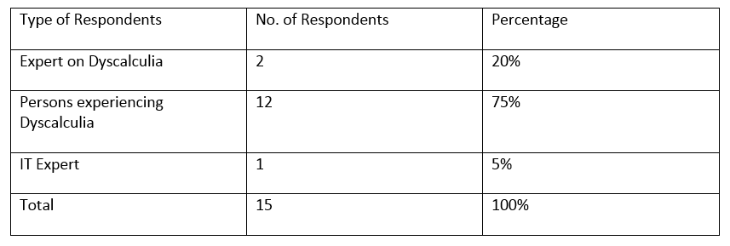

Table 2, Shows the type of respondents and the total number of it. The researchers summarized the evaluation and tabulated the results.

**Table 3. Form of Evaluation**

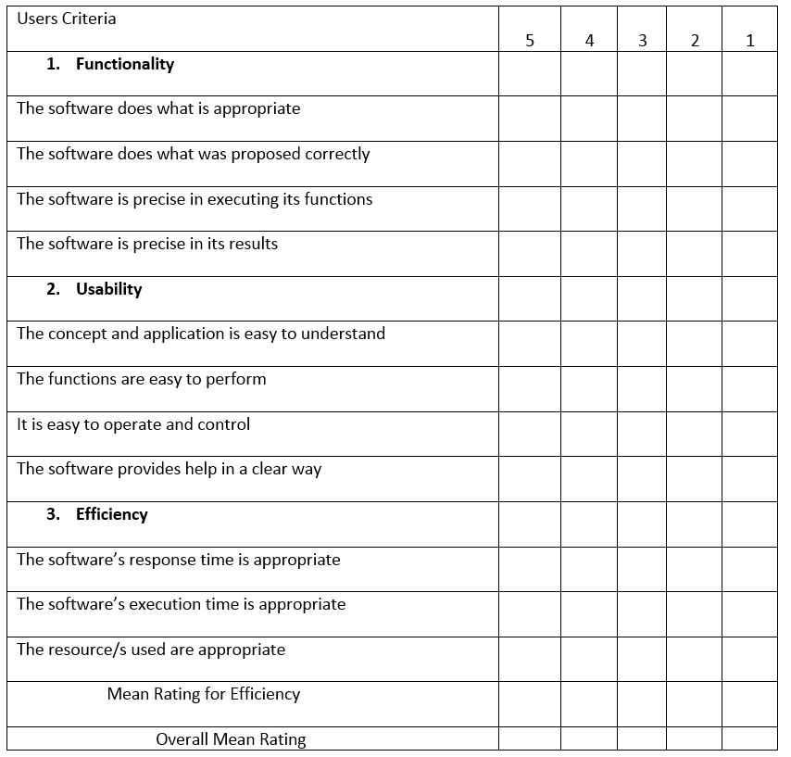

The Table 3 shows the summary of results based on criteria that are evaluated by end users which are experiencing the same kind of symptoms.

**Work Plan**

**Table 4. eDyscalculia Expert System Work Plan**

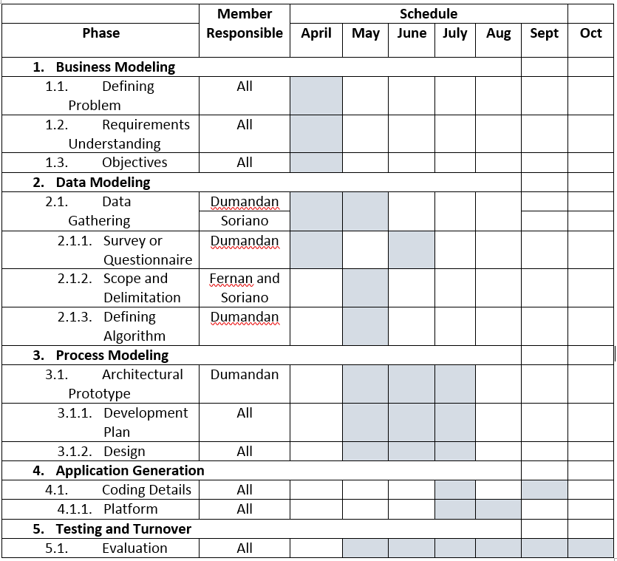

Table 4, shows how the breakdown of works from the creation of the proposed solution up to the evaluation of the application. In creating the work breakdown structure, we follow the rapid application development format.

**Potential for Commercialization**

This application is developed for mobile android devices because it aims to help those people who had experienced and who are experiencing any of the symptoms of dyscalculia, for possible initial remedies for the diagnosed syndrome and making it accessible for the users anytime and anywhere. And this application has the potential to be in the market and be deployed because of the said features of the application and it also has other different use that can help the user in knowing possible treatments to the diagnosed syndrome they have based on the symptoms they are experiencing. This application can be downloaded through Google play store.

**Market Model**

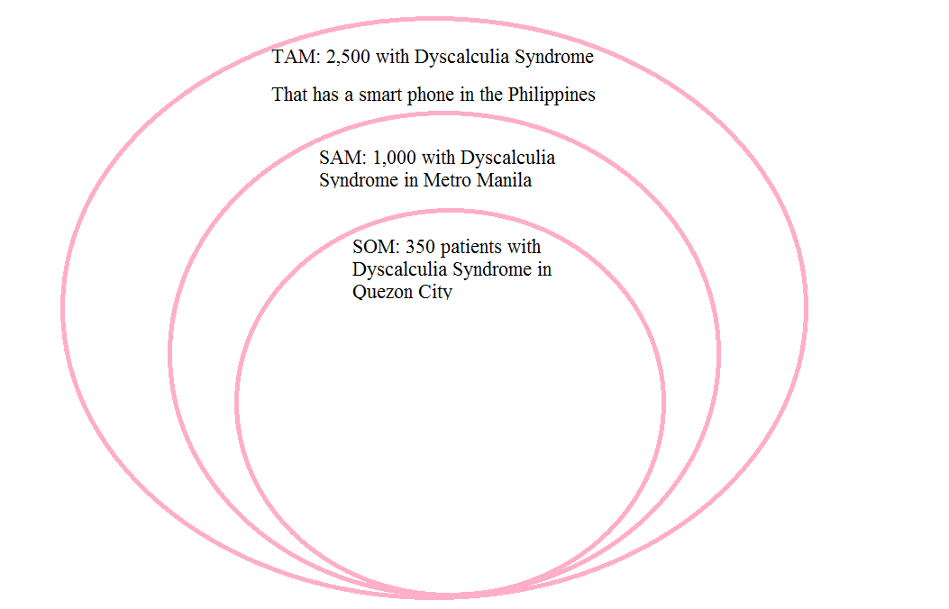

**Figure 4 Market Model**

This figure shows the division of the Total Available Market, Served Available Market and the Target Market for the mobile application, also known as TAM-SAM-SOM.

The TAM or Total Available Market is the total market demand for a product or service. The SAM or Serviceable Available Market is the segment of the TAM targeted by the application which is within the geographical reach of the developers. The SOM or Serviceable Obtainable Market is the portion of SAM that the application can capture.

**Uniqueness**

This is the uniqueness of our application against the existing applications:

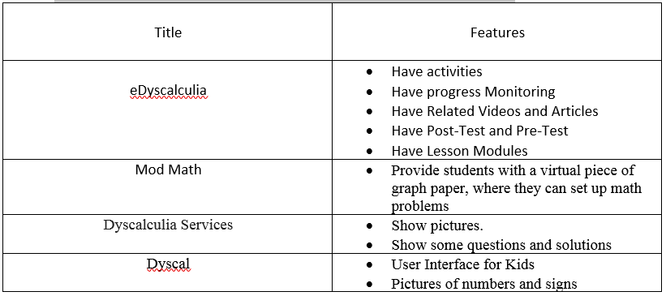

**Benefits**

This will be the benefits of the user while using our application:

* Speed of Adaption - the users will quickly get the application for change and participate in new solution.
* Utilization - this mobile application has a big impact for smart phone users; they will be able to gain knowledge about urinary diseases and its initial remedies.
* Proficiency - this mobile application acts like an initial help that provides activities to the children with dyscalculia.
* Efficiency - the user can be informed about the types and levels of dyscalculia.

**Three Year Product Road Map**

**Table 5. eDyscalculia Mobile Application Three-Year Product Road Map**

|  |  |  |  |
| --- | --- | --- | --- |
|  | 2017 | 2018 | 2019 |
| Performance | Support at least Android Version 5.0 | Support all versions of Android and IOS | Support all versions of Android, IOS and windows phone |
| Price | Free Version | Free Version | Affordable price and additional charge for the partner doctors |
| Key Features | Has the capability to provide the information about dyscalculia needed by the user | Added information about dyscaluclia will be developed | Added another syndrome like dyslexia. |

The three-year product road map is where we planned all the possible improvements for the first 3 years of the deployment and improvement of the application.

**Go-to Market Strategy**

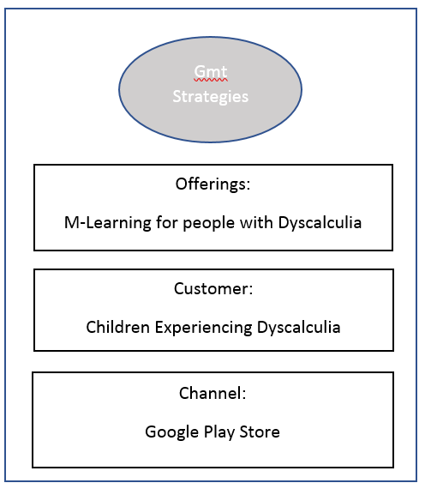

**Figure 5 Go-to Market Strategy**

The figure shows the strategy on how the application will be in the market. The developers used Google play store as a channel for which the mobile application can be offered to the customers.

**Business Model**

**Table 6 eDyscalculia Mobile Application Business Model**

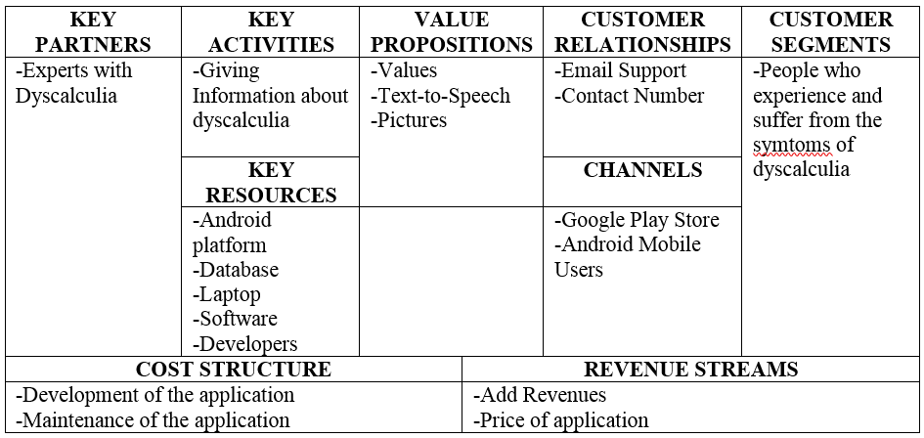

The business model with its 9 components shows the business strategy of our application. The key partners are the people who help us to developed this application, the value proposition is what is the expected use of the application if the customer will be able to get, customer relationship is where the customer can contact us and cost structure is the payment that we used to develop this project.

**References**

Adiguzel et al. (2012) *Adaptive Web-Assisted Learning System for Students with Specific Learning*

*Disabilities: A Needs Analysis Study* Retrieved from: https://eric.ed.gov/?id=EJ1003015

Bainton (2015) *How effective are computer-based interventions in schools for improving mathematical*

*Skills in children with dyscalculia?* Retrieved from: <http://www.ucl.ac.uk/educational-psychology/resources/CS1Bainton15-18.pdf>

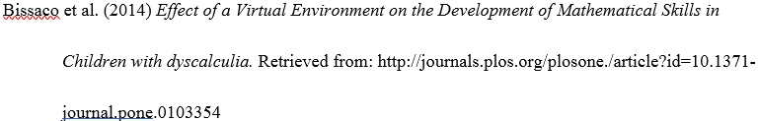

Dehaene & Wilson (2007) *Number Sense and Developmental Dyscalculia* Retrieved from: http://www.

aboutdyscalculia.org/WilsonDehaene_HBDBChapter_2007.pdf

Erkan (2012) *Adaptive Web-Assisted Learning System for Students with Specific Learning Disabilities*

Retrieved from: https://eric.ed.gov/?id=EJ1003015

Guillemot (2009) *Dyscalculia – An Overview of Research on Learning Disability* Retrieved from:

http://www.idt.mdh.se/kurser/ct3340/ht09/ADMINISTRATION/IRCSE09submissions/ircse09_submission_25.pdf

[Peard (2010).](http://www.sciencedirect.com/science/article/pii/S1877042810021208) *Dyscalculia: What is its prevalence? Research evidence from case studies* Retrieved from:

http://www.sciencedirect.com/science/article/pii/S187704281002120